Week 5: Data modelling, storage, filtering and sampling

Objective: In this lab session, you will learn data modelling, filtering techniques, sampling, and data transformation for data warehouse and storage purposes. We will use Google Colab, a Python IDE, for most of our tasks.

Go to https://colab.research.google.com/ to start a new Python notebook. You will need to log in to use Google Colab. You can use your university email or your personal email.

The dataset for this section is the NYC Taxi dataset. See: https://www.nyc.gov/site/tlc/about/tlc-trip-record-data.page

For the session, we will use the yellow taxi trip data for August 2025. The data is in Parquet format. You can download the data on BB or directly download from https://d37ci6vzurychx.cloudfront.net/trip-data/yellow_tripdata_2025-08.parquet

Metadata: https://www.nyc.gov/assets/tlc/downloads/pdf/data_dictionary_trip_records_yellow.pdf

Start by importing the necessary libraries and ingesting the parquet file.
import pyarrow.parquet as pq
trips = pq.read_table('/content/yellow_tripdata_2025-08.parquet')
trips = trips.to_pandas()

Investigate the header:
trips.head()

Let’s create a copy of the data
df=trips.copy() #have a copy of the trip data as df

Deduplicate the dataframe. And index data by the trip_id
df = df.drop_duplicates().reset_index(drop=True)
df['trip_id'] = df.index

Investigate the column name
df.columns

Create a fact-dimension model: Looking at the columns,
we can establish passenger_count_dim, trip_dimension_dim, rate_code_dim, payment_type_dim, datetime_dim, and the fact table. You can develop a similar DFM architecture using a tool like draw.io.
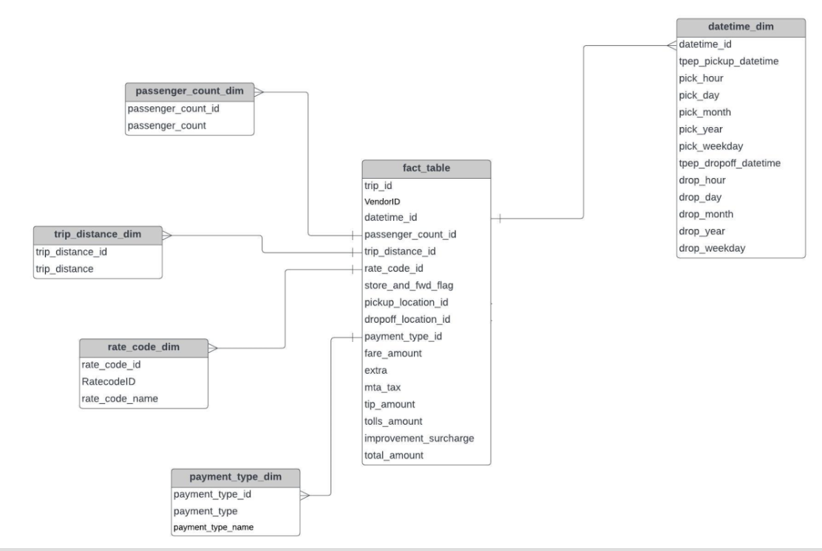
Now, after creating the diagram, let’s go ahead and implement the fact and the dimensions in Python.

Create datetime_dim:
datetime_dim = df[['tpep_pickup_datetime','tpep_dropoff_datetime']].reset_index(drop=True)
datetime_dim['tpep_pickup_datetime'] = datetime_dim['tpep_pickup_datetime']
datetime_dim['pick_hour'] = datetime_dim['tpep_pickup_datetime'].dt.hour
datetime_dim['pick_day'] = datetime_dim['tpep_pickup_datetime'].dt.day
datetime_dim['pick_month'] = datetime_dim['tpep_pickup_datetime'].dt.month
datetime_dim['pick_year'] = datetime_dim['tpep_pickup_datetime'].dt.year
datetime_dim['pick_weekday'] = datetime_dim['tpep_pickup_datetime'].dt.weekday

datetime_dim['tpep_dropoff_datetime'] = datetime_dim['tpep_dropoff_datetime']
datetime_dim['drop_hour'] = datetime_dim['tpep_dropoff_datetime'].dt.hour
datetime_dim['drop_day'] = datetime_dim['tpep_dropoff_datetime'].dt.day
datetime_dim['drop_month'] = datetime_dim['tpep_dropoff_datetime'].dt.month
datetime_dim['drop_year'] = datetime_dim['tpep_dropoff_datetime'].dt.year
datetime_dim['drop_weekday'] = datetime_dim['tpep_dropoff_datetime'].dt.weekday
datetime_dim['datetime_id'] = datetime_dim.index

# datetime_dim = datetime_dim.rename(columns={'tpep_pickup_datetime': 'datetime_id'}).reset_index(drop=True)
datetime_dim = datetime_dim[['datetime_id', 'tpep_pickup_datetime', 'pick_hour', 'pick_day', 'pick_month', 'pick_year', 'pick_weekday','tpep_dropoff_datetime', 'drop_hour', 'drop_day', 'drop_month', 'drop_year', 'drop_weekday']]
#
datetime_dim.head()

Create passenger count dim:
passenger_count_dim = df[['passenger_count']].reset_index(drop=True)
passenger_count_dim['passenger_count_id'] = passenger_count_dim.index
passenger_count_dim = passenger_count_dim[['passenger_count_id','passenger_count']]
passenger_count_dim.head()

Create trip_distance_dim:
trip_distance_dim = df[['trip_distance']].reset_index(drop=True)
trip_distance_dim['trip_distance_id'] = trip_distance_dim.index
trip_distance_dim = trip_distance_dim[['trip_distance_id','trip_distance']]
trip_distance_dim.head()

Create rate_code_dim:
rate_code_type = {
1:"Standard rate",
2:"JFK",
3:"Newark",
4:"Nassau or Westchester",
5:"Negotiated fare",
6:"Group ride"
}
rate_code_dim = df[['RatecodeID']].reset_index(drop=True)
rate_code_dim['rate_code_id'] = rate_code_dim.index
rate_code_dim['rate_code_name'] = rate_code_dim['RatecodeID'].map(rate_code_type)
rate_code_dim = rate_code_dim[['rate_code_id','RatecodeID','rate_code_name']]
rate_code_dim.head()

Create payment_type_dim:
payment_type_name = {
1:"Credit card",
2:"Cash",
3:"No charge",
4:"Dispute",
5:"Unknown",
6:"Voided trip"
}
payment_type_dim = df[['payment_type']].reset_index(drop=True)
payment_type_dim['payment_type_id'] = payment_type_dim.index
payment_type_dim['payment_type_name'] = payment_type_dim['payment_type'].map(payment_type_name)
payment_type_dim = payment_type_dim[['payment_type_id','payment_type','payment_type_name']]
payment_type_dim.head()

Create a fact table:
fact_table = df.merge(passenger_count_dim, left_on='trip_id', right_on='passenger_count_id') \
.merge(trip_distance_dim, left_on='trip_id',\ right_on='trip_distance_id') \
.merge(rate_code_dim, left_on='trip_id', right_on='rate_code_id') \
.merge(datetime_dim, left_on='trip_id', right_on='datetime_id') \
.merge(payment_type_dim, left_on='trip_id',\right_on='payment_type_id') \
[['trip_id','VendorID', 'datetime_id', 'passenger_count_id',
'trip_distance_id', 'rate_code_id', 'store_and_fwd_flag',\
'payment_type_id', 'fare_amount', 'extra', 'mta_tax', 'tip_amount', 'tolls_amount',
'improvement_surcharge', 'total_amount']]

Investigate the fact_table:
fact_table.head()

Task: Load the dimension and fact tables into a SQLite database.
#Create a connection to the SQLite database.
import sqlite3
conn = sqlite3.connect('nyc_taxi_data.db')

Load each of the dimension DataFrames (`datetime_dim`, `passenger_count_dim`, `trip_distance_dim`, `rate_code_dim`, `payment_type_dim`) into separate tables in the SQLite database.

Write each dimension DataFrame to a separate table in the SQLite database.
datetime_dim.to_sql('datetime_dim', conn, if_exists='replace', index=False)
passenger_count_dim.to_sql('passenger_count_dim', conn, if_exists='replace', index=False)
trip_distance_dim.to_sql('trip_distance_dim', conn, if_exists='replace', index=False)
rate_code_dim.to_sql('rate_code_dim', conn, if_exists='replace', index=False)
payment_type_dim.to_sql('payment_type_dim', conn, if_exists='replace', index=False)

Load the `fact_table` DataFrame into a table in the SQLite database.
fact_table.to_sql('fact_table', conn, if_exists='replace', index=False)

Verify data loading
Read some data back from the SQLite tables to ensure the data was loaded correctly.
import pandas as pd

# Read data from a dimension table
dim_query = "SELECT * FROM datetime_dim LIMIT 5;"
dim_df = pd.read_sql_query(dim_query, conn)
display(dim_df.head())

# Read data from the fact table
fact_query = "SELECT * FROM fact_table LIMIT 5;"
fact_df = pd.read_sql_query(fact_query, conn)
display(fact_df.head())

Close the connection to the SQLite database.
import sqlite3
conn = sqlite3.connect('nyc_taxi_data.db')
Sampling and filtering on the `fact_table` in the "transformed_nyc_taxi_data.db" database.

Write and execute a SQL query to select a random sample of rows from the `fact_table`.
sampling_query = "SELECT * FROM fact_table ORDER BY RANDOM() LIMIT 1000;"
sampled_fact_table = pd.read_sql_query(sampling_query, conn)
display(sampled_fact_table.head())

Write and execute SQL queries to filter the `fact_table` based on specific criteria (e.g., payment type, total amount, passenger count).
# Filter by payment_type_id = 1 (Credit card)
payment_type_filter_query = "SELECT * FROM fact_table WHERE payment_type_id = 1;"
payment_type_filtered_df = pd.read_sql_query(payment_type_filter_query, conn)
display(payment_type_filtered_df.head())

# Filter by total_amount > 50
total_amount_filter_query = "SELECT * FROM fact_table WHERE total_amount > 50;"
total_amount_filtered_df = pd.read_sql_query(total_amount_filter_query, conn)
display(total_amount_filtered_df.head())

# Filter by passenger_count_id > 2
passenger_count_filter_query = "SELECT * FROM fact_table WHERE \
passenger_count_id > 2;"
passenger_count_filtered_df = pd.read_sql_query(passenger_count_filter_query, conn)
display(passenger_count_filtered_df.head())

#close the connection to the SQLite database
conn.close()

